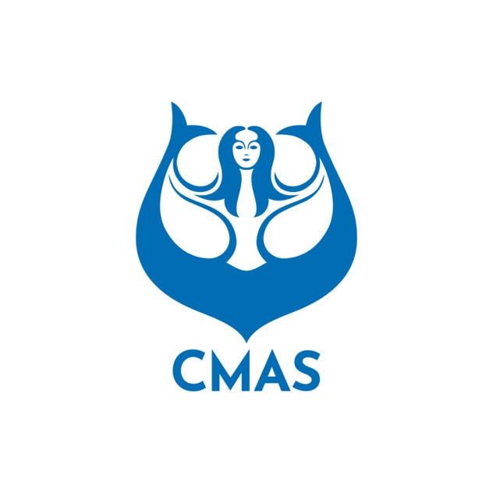
ANNEX 1
INITIAL ENTRIES FROM (Before September 15th 2026)
Please complete this form and send it to CMAS HQ and Organising Committee by e-mail: angel.giannakaki@sport.cmas.org / subacquea@fipsas.it

Name of the Federation |  | NOC Code
Contact Person |  | Phone No.
Function |  | Mobile No.

Team Officials | Males |  | Females
Athletes | Males |  | Females
Judge | Males |  | Females
Declaration Form: By registering my federation in this championship, I undertake to respect the statutes, regulations and directives of the CMAS.
Date and Signature: ________________
Insurance: I hereby declare that all the delegation members have valid health insurance for the duration of the stay, which covers the full extent of the consequences of accidents and reimbursement for the costs of treatment and rehabilitation following the accident that may occur during the stay.
Date and Signature: ________________
Consent to the publication of imagery: I grant the Organising Committee permission for my imagery, full name, nationality and voice to be recorded during the competition. All team members (or legal representatives) signed the relevant authorisation form.
Date and Signature: ________________
Antidoping: I, the undersigned, am responsible for all the delegation members acknowledging WADA Antidoping Rules and CMAS Antidoping Rules.
- The expenses regarding the controls in competition belong to the organisers. In case of eventual supplementary analysis requested by WADA related to the bio-physiology of an athlete as ex ABP (athlete biological passport), the expenses belong to her/ his national federation.
Date and Signature: ________________
Please check CMAS Procedures and Finswimming rules for participation in CMAS Championship.
The President | Date
(Full name in block letters)
President Signature/stamp)

ANNEX 2
HOTEL BOOKING FORM (Before September 30th 2026)
Please complete this form and send to CMAS HQ and FIPSAS by e-mail: angel.giannakaki@sport.cmas.org / subacquea@fipsas.it
Country:
Federation:
Telephone: | Fax: | e-mail:

Please complete: | Number of Rooms | Date
 | Number of Rooms | From | To
Single
Double / Triple
 | Number of Rooms | Date
 | Number of Rooms | From | To
Single
Double / Triple

Extra Nights: If you need extra nights, please fill in the following.
Please complete: | Number of Rooms | Date
 | Number of Rooms | From | To
Single
Double / Triple
 | Number of Rooms | Date
 | Number of Rooms | From | To
Single
Double / Triple

 | Date:
(President Signature / stamp) |  | (Full name in block letters)

ANNEX 3
COMPETITORS LIST FORM (Before October 31st 2026)
Please complete this form and send to CMAS HQ and FIPSAS by e-mail: angel.giannakaki@sport.cmas.org / subacquea@fipsas.it
Country:
Federation
Competitors |  | Men |  |  |  | Women
Officials |  | Men |  |  |  | Women
n. | NAME |  | FIRST NAME |  | Athlete, Accompanying person, Trainer, Delegation Chief, Doctor, Judge, Other |  | Passport number | Male | Female | Disability class | Single  room
1
2
3
4
5
6
7
8
9
10
11
12
13
14
15
16
17
18
19
20

ARRIVAL | Date: |  | Time
Airport |  |  | Flight No.
DEPARTURE | Date: |  | Time
Airport |  |  | Flight No.

 | Date:
(President Signature / stamp) |  | (Full name in block letters)

